I have followed the below steps and error  I am getting

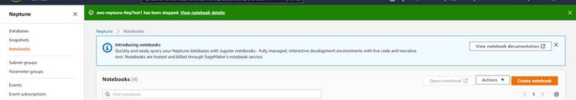

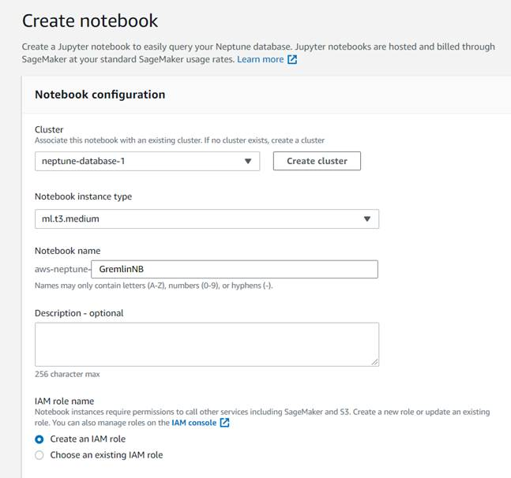

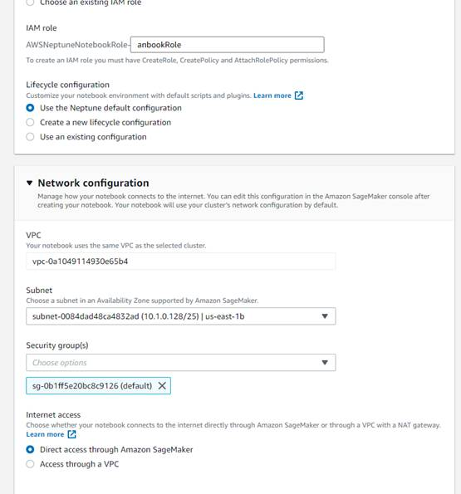

When I tried to ping from notebook terminal it get hangded and when I terminate I got the following result

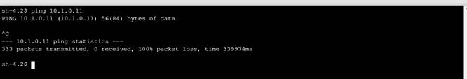

However, I am able to resolve the DNS using nslookup from the notebook

